**Table of Contents**

|  |  |  |
| --- | --- | --- |
| **S. No.** | **Chapter** | **Page No.** |
| 1 | Project Description | 2 |
| 2 | Source Code | 3 |
| 3 | Screenshots | 22 |

**Chapter 1**

**Project Description – PARLOUR STUDIO**

The objective of this project to create the parlour studio website that showcase my knowledge in HTML, CSS, JS, Bootstrap framework. The website designed in a way to be visually appealing by using animation effects, gradient colors as background.

The website includes multiple pages such as Login page, Home page, Features page, Services page, Testimonial page, meet us page

In Login page of our **PARLOUR STUDIO** website gets username and password, user credentials validation done through java script code here it checks three conditions.

* Username length must not be equal to zero.
* Password length must have minimum 8 characters.

If above conditions satisfy it redirects to home page otherwise alert message will pop up as Login Failed!

Home page contains **PARLOUR STUDIO** display banner. This banner is achieved using CSS styles where background image property is used. The navigation bar styled through list where each list value having anchor tag which redirect to respective pages. Using keyframe style welcome card is displayed on the home page.

Using bootstrap framework in our webpage achieved automatic running carousel which contains product images by clicking them it redirects to respective pages.

In feature page consists of the previous experience, special services and customer reviews.

Services page contain about our treatment and special services provided in the parlour which also includes details about special packages, offers and details on membership if required

Meet us page contains the details about the address, phone number and details of other branches. This helps the user to interact easily.

**Chapter 2**

**SOURCE CODE**

**index.html**

<html>

<head>

<title> Beauty parlour shop website design</title>

<link rel="stylesheet" href ="style.css">

<link rel="stylesheet"

href="https://cdn.jsdelivr.net/npm/@fortawesome/fontawesome-free@6.2.1/css/fontawesome.min.css">

<meta name="viewport" content="width= device-width,initial-scale=1">

<script src="https://cdn.jsdelivr.net/gh/cferdinandi/smooth-scroll/dist/smooth-scroll.polyfills.min.js"></script>

</head>

<body>

<section id="banner">

<img src="logo.jpg" class="logo">

<div class="banner-text">

<h1>Parlour studio</h1>

<p>Beauty brings you more confidence</p>

<div class="banner-btn">

<a href="#">Find out</a>

<a href="#">Read more</a>

</div>

</div>

</section>

<div id="sideNav">

<nav>

<ul>

<li><a href="#banner">Home</a></li>

<li><a href="#features">Features</a></li>

<li><a href="#service">Services</a></li>

<li><a href="#testimonial">Testimonials</a></li>

<li><a href="#footer">Meet us</a></li>

</ul>

</nav>

</div>

<div id="menuBtn">

<img src="images/menu.png" id="menu">

</div>

<!--Features-->

<section id="features"></section>

<div class="title-text">

<p>FEATURES</p>

<H1> Why choose us</H1>

</div>

<div class="feature-box">

<div class="features">

<h1> Experienced staff</h1>

<div class="features-desc">

<div class="feature-icon">

<i class="fa fa-shield"></i>

<div class="features-img">

<img src="images/makeupgirl.jpg">

</div>

<div class="features-text">

<p>Parlour studio is a user-friendly,cloud-based parlour management

to all of our customer.Beauty is the gift of god and transmitted

other generation.the beauty parlour shop is the need of every age

of men women and children famours poet keats defined the word beauty as

: " A thing of beauty is a joy for ever: Beauty parlour is a very important shop to make the people

good looking by application of cosmetics treatment of hair and nourishment of skin by various methods .

Life style is fast changing in the modern era and the women have become more conscious about their

make up the status of women has improved a lot and is improving further

. Tis has resulted in their life style changing. Also their economic independence encourages them

to resort this type of services.</p></p>

</div>

</div>

</div>

</div>

</div>

</section>

<!--Service-->

<section id="service">

<div class="title-text" >

<p>SERVICES</p>

<h1>we provide better</h1>

</div>

<div class="service-box"></div>

<div class="img-area"></div>

<div class="single.img"></div>

<img src="images/pic-1.jpg">

<div class="overlay"></div>

<div class="service-desc">

<h3>parlouring</h3>

<p> parlour studio provides you too the best look by our cosmetics

treatmentfor people.we can also done for the bridal and groom.book your pre-booking quickly.

This is test under description of parlour studio foundation.</p>

<hr>

</div>

</div>

<div class="single-img"></div>

<img src="images/pic-2.jpg">

<div class="overlay"></div>

<div class="service-desc">

<h3>Bleaching</h3>

<p> Bleach makes skin look fairer and radiant in just about 15 minutes

It bleaches facial hair to match according to your skin tone.our services

include fruits facial,face bleach,pedicure spa,manicure,full body bleaching.

also we only use natural bleach powder.book your online pre-booking quickly.

This is test under description of parlour studio foundation.</p>

<hr>

</div>

<div class="single-img"></div>

<img src="images/pic-3.jpg">

<div class="overlay"></div>

<div class="service-desc">

<h3>Threading</h3>

<p> Eyebrow threading is give wonderfull look for all men and women.

we can do in a very low price.book your pre-bookig quickly.

This is test under description of parlour studio foundation.</p>

<hr>

</div>

<div class="single-img"></div>

<img src="images/pic-4.jpg">

<div class="overlay"></div>

<div class="service-desc">

<h3>Hair styling</h3>

<p> all natural hair colouring services include root touchup,global colouring,

streaking,block colouring,and creative colouring.all our hair

colouring products are ammonia-free.our hair experts can transform your

entire look with just a few streaks of our ammonia-free hair colour.book your online pre-booking quickly,

This is test under description of parlour studio foundation.</p>

<hr>

</div>

</div>

</div>

</div>

</section>

<!--Testimonial-->

<section id ="testimonial">

<div class="title-text">

<p> TESTIMONIAL</p>

<h1> what client says</h1>

</div>

<div class="testimonial-row">

<div class="testimonial-col">

<div class="user">

<img src="images/sam.jpg">

<div class="user-info">

<h4>SAMANTHA</h4>

<small>@samantha</small>

</div>

</div>

<p>My experience at parlour studio has always been a professional

and pleaurable one.very pleasent atmosphere,especially considering

the clean area .greeted very warmly upon my entrance and seated almost immediately.

</p>

</div>

<div class="testimonial-col">

<img src="images/alia.jpg">

<div class="user-info">

<h4>ALIABHAT</h4>

<small>@aliabhat</small>

</div>

<p> parlour studio is amazing .I had gotten an unfortunate haircut

from another establishment and she spent the time fixing every

detail oh my hair until it was perfect.she's so skilled and so sweet.highly recommend.

</p>

</div>

<div class="testimonial-col">

<img src="images/v.jpg">

<div class="user-info">

<h4>KIM TAEHYUNG</h4>

<small>@kim taehyung</small>

</div>

<p> Easy appointments,welcoming staff,and talented employees.

eventhough I'm a men coustomer it is very comfortable to me.

I was colouring my hair,and it is so good.

</p>

</div>

</div>

</section>

<!--footer-->

<section id ="footer">

<img src="images/icon.jpg" class="footer-img">

<div class="title-text">

<p> CONTACT</p>

<h1> Visit shop Today</h1>

</div>

<div class="footer-row">

<div class="footer-left" >

<h1>Opening Hours</h1>

<p> Monday to Friday- 9am to 9pm</p>

<p> Saturday and Sunday-8am to 11pm</p>

</div>

<div class="footer-right">

<h1> Get In Touch</h1>

<p> #30 abc colony,xyz city IN </p>

<p>parlour@web.com </p>

<p> +91 8962367890</p>

</div>

</div>

<div class="social-links">

<i class="fa fa-facebook"></i>

<i class="fa fa-instagram"></i>

<i class="fa fa-twitter"></i>

<i class="fa fa-fa-youtube-play"></i>

</div>

</section>

<script>

var menuBtn=document.getElementById("menuBtn")

var sideNav=document.getElementById("sideNav")

var menu=document.getElementById("menu")

menuBtn.onclick=function(){

if(sideNav.style.right =="-250px"){

sideNav.style.right ="0";

}

else{

sideNav.style.right ="-250px";

}

}

var scroll = new SmoothScroll('a[href*="#"]', {

speed: 1000,

speedAsDuration: true

});

</script>

</body>

</html>

**STYLE.CSS**

*{

margin: 0;

padding:0;

}

#banner{

background:url(banner.jpg);

background-size: cover;

background-position: center;

height:100vh;

}

.logo{

width: 70px;

position:absolute;

top:3%;

left:5%;

}

.banner-text{

text-align: center;

color:black;

padding-top:180px;

}

.banner-text h1{

font-size: 100px;

font-family:'kaushan script',cursive;

}

. banner-text p {

font-size: 20px;

font-style: italic;

}

.banner-btn{

margin: 70px auto 0;

}

.banner-btn a{

width: 120px;

text-decoration: none;

display:inline-block;

margin:0 10px;

padding: 10px 0;

color:black;

border:0.5px solid brown;

}

.banner-btn a:hover{

border:1px solid #009688;

background: #009688;

transition: 1s;

}

#sidenav{

width:120px;

height: 100vh;

position: fixed;

right:0;

top:0;

background:whitesmoke;

z-index:2;

transition: 0.5s;

}

nav ul li{

list-style: none;

margin: 50px 20px;

}

nav ul li a {

text-decoration: none;

color:black;

}

#menuBtn{

width:40px;

height:40px;

background:pink;

text-align: center;

position:fixed;

right:20px;

top:20px;

border-radius: 3px;

z-index:3;

cursor:pointer;

}

#menuBtn img{

width:20px;

margin-top: 20px;

}

@media screen and(max-width: 770px){

.banner-text h1{

font-size: 44px;

}

banner-btn a{

display:block;

margin:20px auto;

}

}

/*--feature--*/

#feature{

width:100%;

padding: 100px 20;

}

.title-text{

text-align:center;

padding-bottom: 100px;

}

.title-text p{

margin:auto;

font-size: 20px;

color:black;

font-weight: bold;

position:relative;

z-index:1;

display:inline-block;

}

.title-text p::after{

content:'';

width:50px;

height:50px;

background:linear-gradient(#fc8eac,#fff) ;

position:absolute;

top:-20px;

left:0;

z-index:-1;

transform:rotate(10deg);

border-top-left-radius:35px;

border-bottom-right-radius: 35px;

}

.title-text h1{

font-size:35px;

}

.feature-box{

width:80%;

margin:auto;

display:flex;

flex-wrap:wrap;

align-items:left;

text-align:left;

}

.features{

flex-basis: 50%;

}

.features-img{

flex-basis:50%;

margin:auto;

}

.features-img img{

width:70%;

border-image-width: 50%;

border-radius: 10px;

}

.features h1{

text-align: left;

margin-bottom: 10px;

font-weight: 100;

color: black;

}

.features-desc{

display:flex;

align-items:center;

margin-right: 40px;

}

/*--service--*/

#service{

width:100%;

padding:70px 0;

background:#efefef;

}

.service-box{

width:65%;

display:flex;

flex-wrap:wrap;

justify-content: space-around;

margin: auto;

}

.img-area{

display: flex;

flex-wrap: wrap;

flex-direction: row;

align-items: center;

justify-content: center;

}

.single-img{

padding: 0 20px 20px;

}

/*--testimonial--*/

#testimonial{

width:100%;

padding:70px 0;

}

.testimonial-row{

width:80%;

margin:auto;

display:flex;

justify-content: space-between;

align-items:flex-start;

flex-wrap:wrap;

}

.testimonial-col{

flex-basis:28%;

padding:10px;

margin-bottom:30px;

border-radius: 5px;

box-shadow:0 10px 20px 3px #fc8eac;

cursor:pointer;

}

/*--footer--*/

#footer{

padding:100px 0 20px;

background:#efefef;

position: relative;

}

.footer-row{

width:80%;

margin:0 auto;

display:flex;

justify-content: space-between;

flex-wrap: wrap;

}

.footer-left,.footer-right{

flex-basis:45%;

padding:20px;

margin-bottom:20px;

}

.footer-right{

text-align: right;

}

.footer-row h1{

margin:10px 0;

}

.footer-row p{

line-height:35px;

}

.footer-img{

max-width:370px;

opacity:0.1;

position:absolute;

left:50%;

top:35%;

transform: translate(-50%,-50%);

}

**Login.html**

<!DOCTYPE html>

<html lang="en">

<head>

<meta charset="UTF-8">

<meta name="viewport" content="width=device-width,initial-scale=1.0">

<title> login page</title>

<link rel="stylesheet" href="login.css">

</head>

<body>

<section>

<div class="form-container">

<h1>login form</h1>

<form action="index.html">

<div class="control">

<label for= "name">Name</label">

<input type="text" name="name" id="name">

</div>

<div class="control">

<label for="psw">Password</label>

<input type="password" name="psw" id="psw">

</div>

<span><input type="checkbox">Remember me.</span>

<div class="control">

<input type="submit" value="login">

</div>

</form>

<div class="link">

<a href="#">Forgot Password?</a>

</div>

</div>

<a href ="#"

</div>

</section>

</body>

</html>

**Login.css**

*{

margin:0;

padding:0;

box-sizing: border-box;

}

body{

font-family: "open sans";

color:white;

}

section{

position:relative;

height:100vh;

width:100%;

background:url("./images/login.jpg");

background-size: cover;

background-position: center;

}

.form-container{

position:absolute;

top:50%;

left:50%;

transform:translate(-50%,-50%);

background: linear-gradient(rgba(0,0,0,0.3),(rgba(0,0,0,0.3)));

width:380px;

padding:50px 30px;

border-radius:10px ;

box-shadow: 7px 7px 60px #000;

}

h1{

text-transform: uppercase;

font-size: 2em;

text-align: center;

margin-bottom: 2em;

}

.control input{

width: 100%;

display:block;

padding:10px;

color:#222;

border:none;

outline:none;

margin:1em 0;

}

.control input[type="submit"]{

background:palevioletred;

color:white;

text-transform:uppercase;

font-size: 1.2em;

opacity:.7;

transition:opacity.3s ease;

}

.control input[type="submit"]:hover{

opacity:1;

}.link{

text-align: center;

}

.link a{

text-decoration: none;

color:white;

opacity:.6;

transition:opacity .3s ease;

}

.linka:hover{

opacity:1;

}

**Chapter 3**

**SCREENSHOTS**

1. Welcome page of parlour website with login form

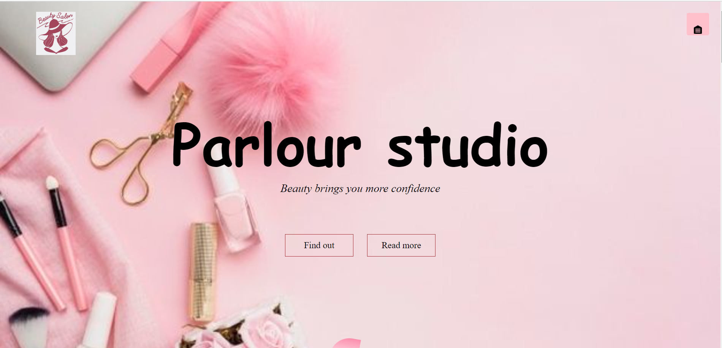

(fig. 3.1)

1. Login using username and valid password if not alert pop ups “Login Failed”.

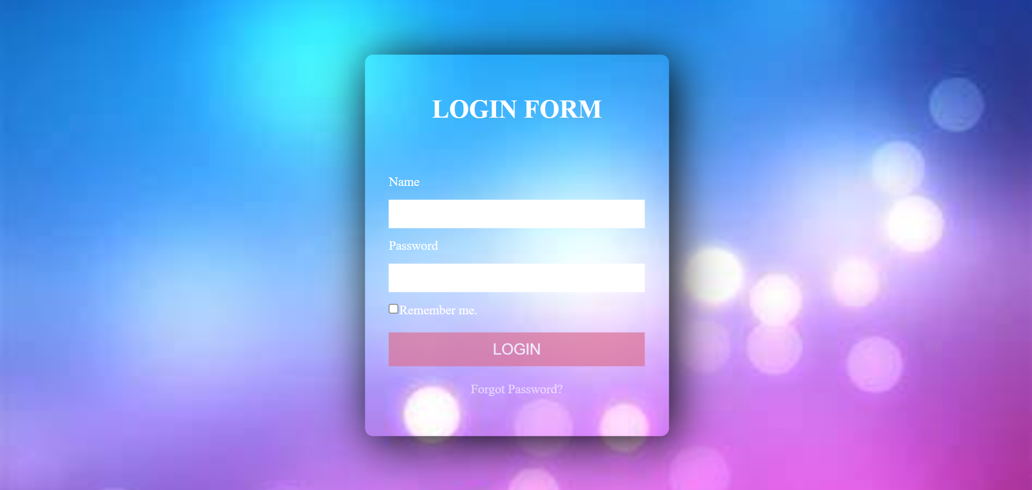

(fig. 3.2)

1. Home Page of parlour which containes Navigation bar , Welcome Card , Carousel of Products,

Contact Information.We can move to next page through either navigation bar or using carousel

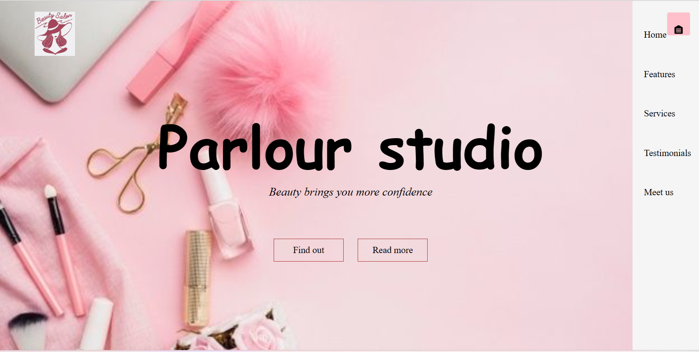

(fig. 3.3)

1. In features page contain about a history of our selfs.

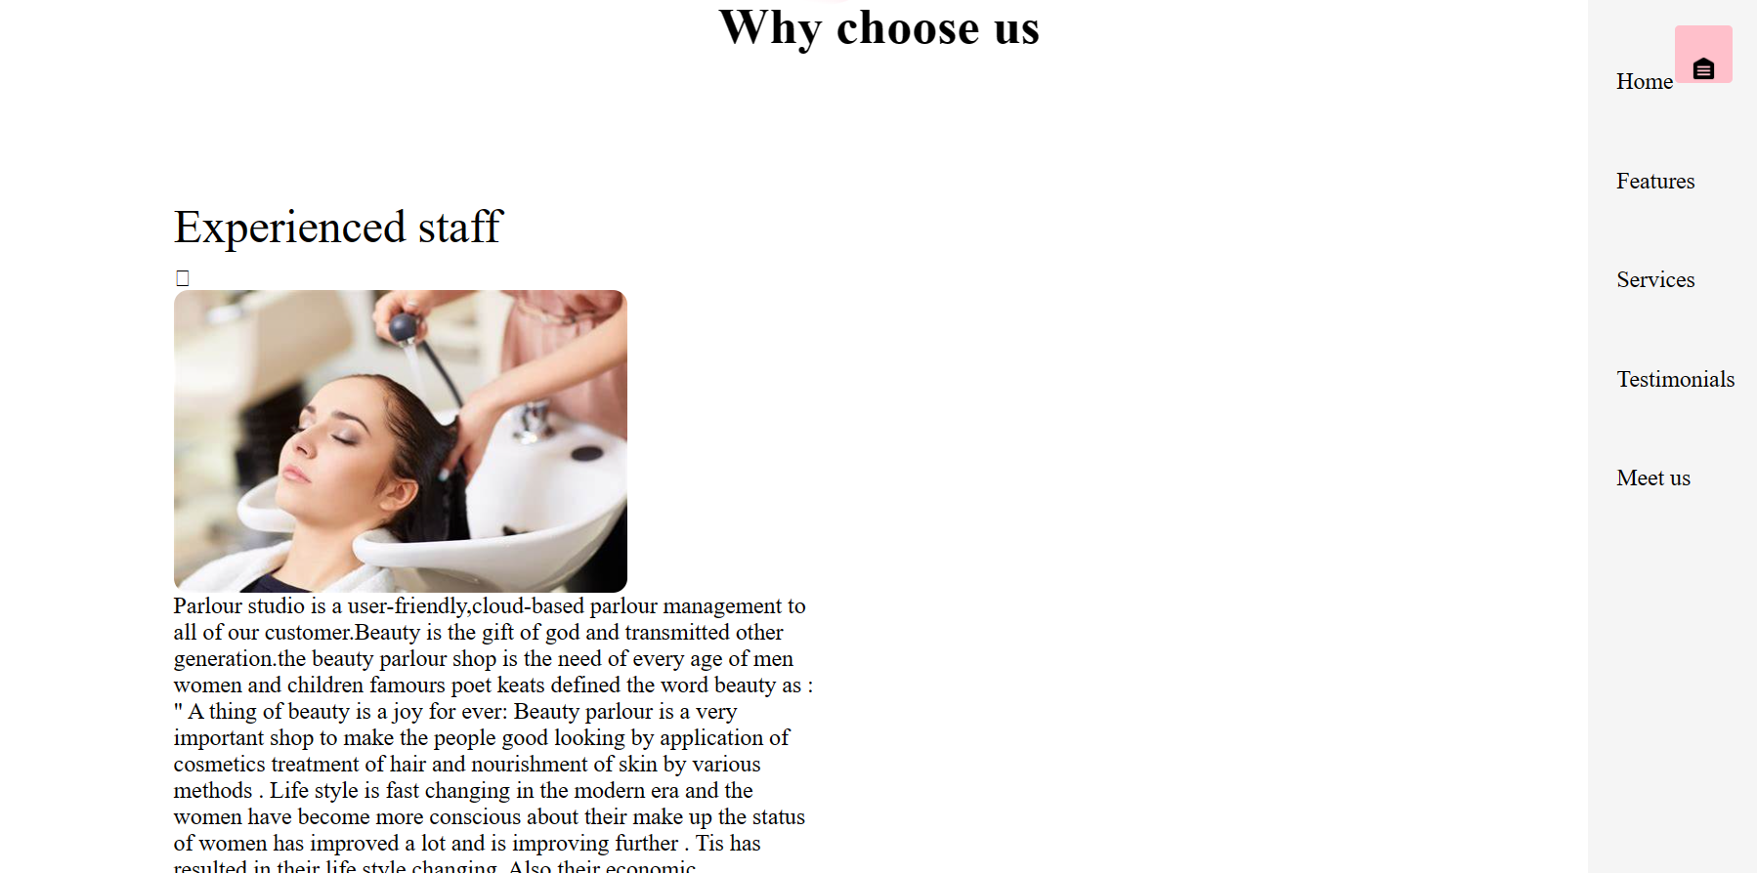

(fig. 3.4)

1. In Services page about what type services we do.

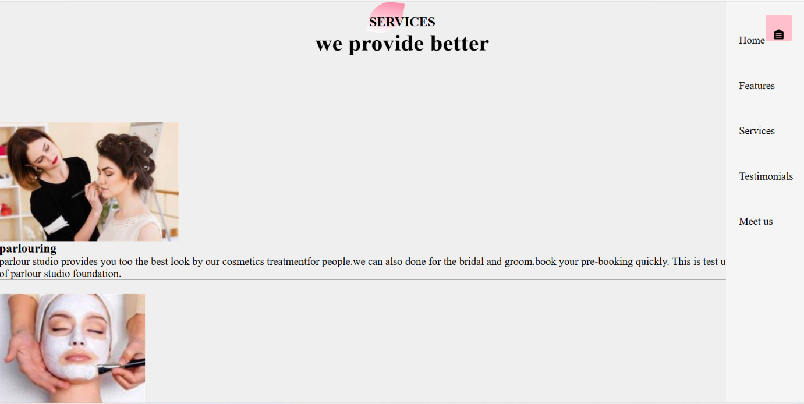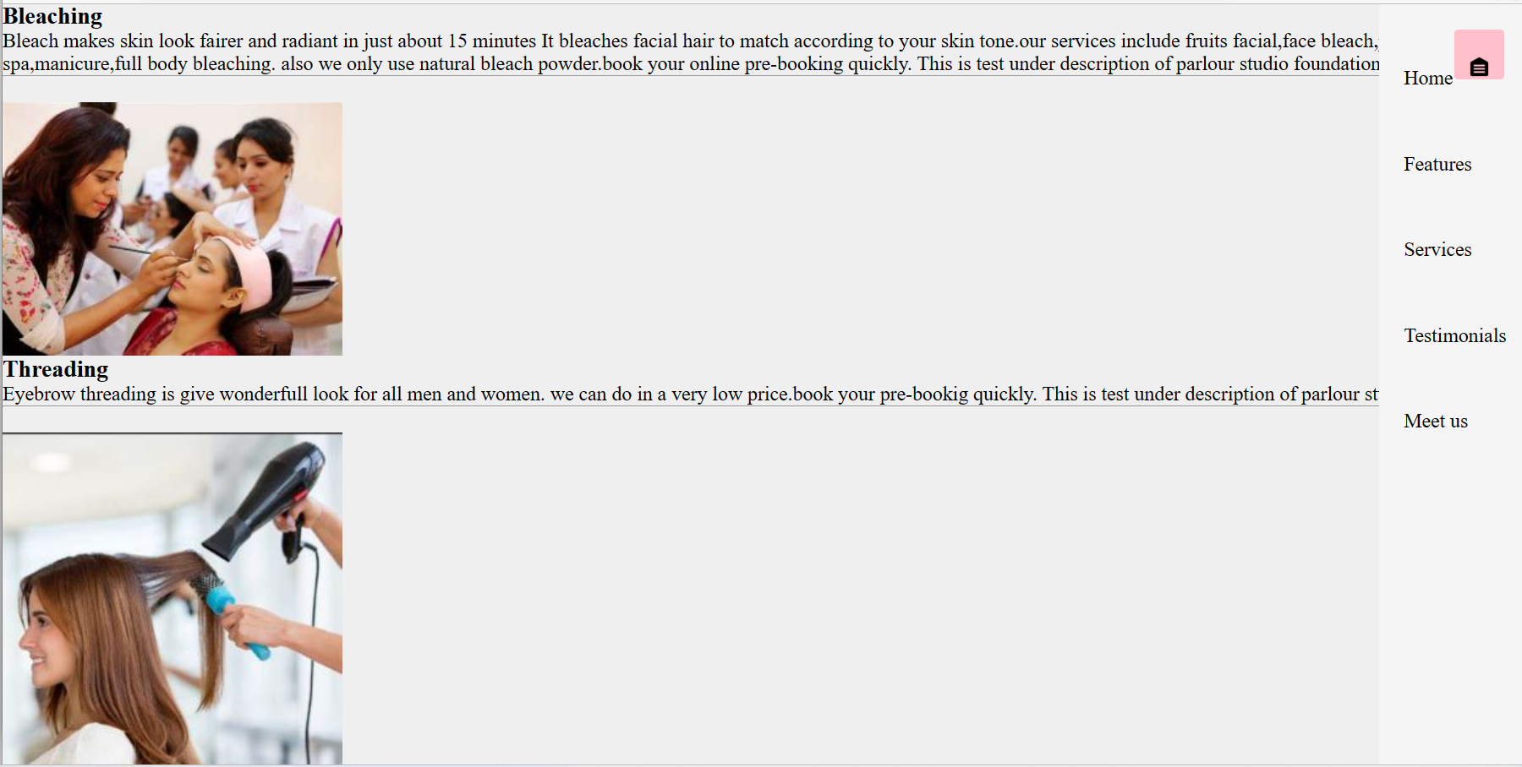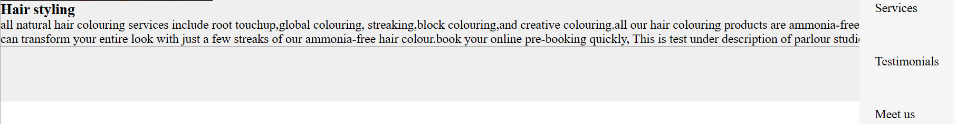 (fig 3.4)

f. In testimonal page about how client react our treatment.

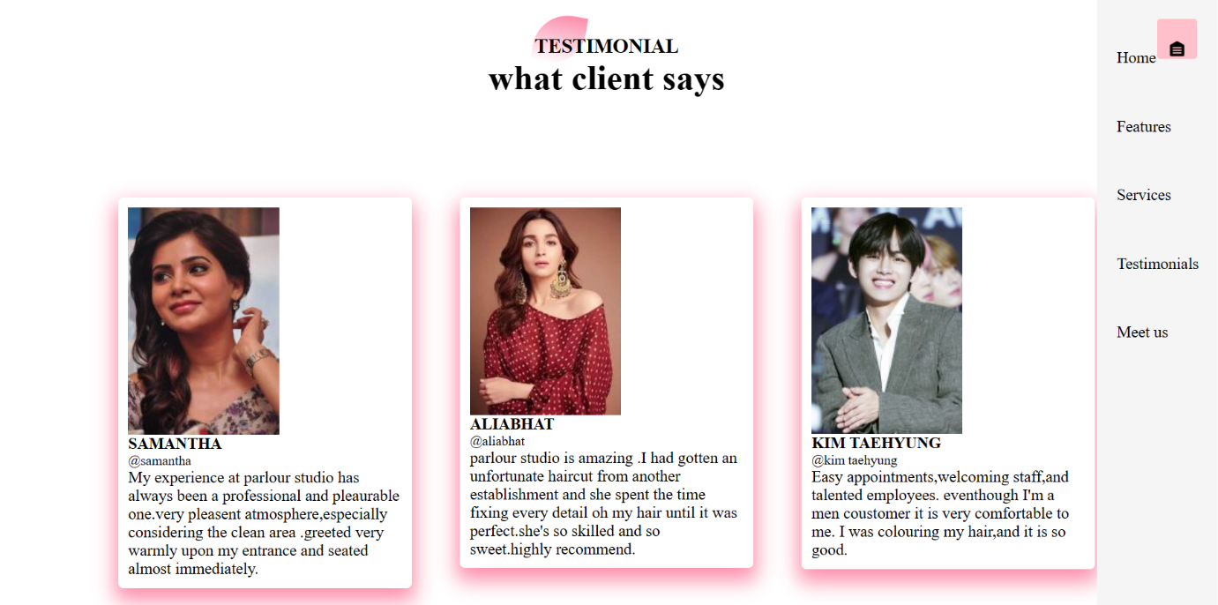

(fig. 3.5)

g.In meet us page contain about our contact and timings of our studio.

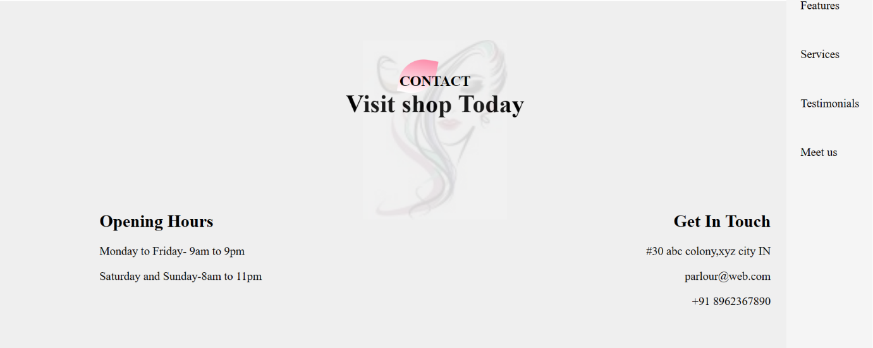

(fig 3.6)